Problem 1: Secure Student Record Encryption
# Install library
!pip install cryptography
from cryptography.fernet import Fernet
# Generate key
key = Fernet.generate_key()
with open("student.key", "wb") as f:
f.write(key)
cipher = Fernet(key)
name = input("Enter Student Name: ")
reg = input("Enter Register Number: ")
marks = input("Enter Marks: ")
data = f"Name:{name}\nRegister:{reg}\nMarks:{marks}"
encrypted = cipher.encrypt(data.encode())
with open("student_records.enc","wb") as f:
f.write(encrypted)
print("\nStudent Record Encrypted Successfully!")
# Decryption
print("\nDecrypting...\n")
with open("student_records.enc","rb") as f:
encrypted_data = f.read()
decrypted = cipher.decrypt(encrypted_data)
print(decrypted.decode())
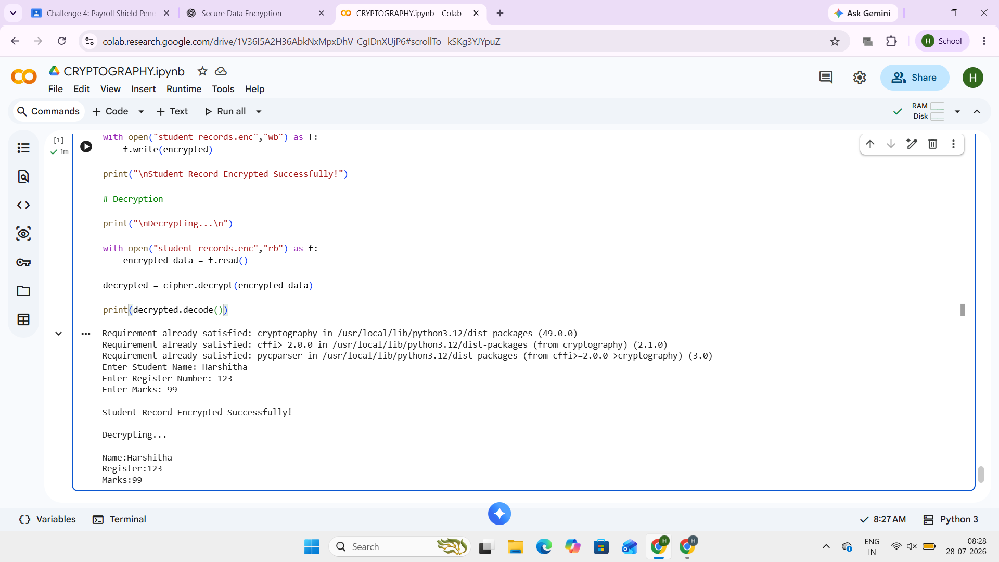
Problem 2: Secure Notes Application
!pip install cryptography
from cryptography.fernet import Fernet
key = Fernet.generate_key()
cipher = Fernet(key)
note = input("Enter Secret Note:\n")
encrypted = cipher.encrypt(note.encode())
with open("notes.enc","wb") as f:
f.write(encrypted)
print("Encrypted Successfully")
print("\nProvide Secret Key to Read Notes")
user_key = input("Enter Key: ")
if user_key.encode()==key:
with open("notes.enc","rb") as f:
data=f.read()
print("\nOriginal Note:")
print(cipher.decrypt(data).decode())
else:
print("Wrong Key")
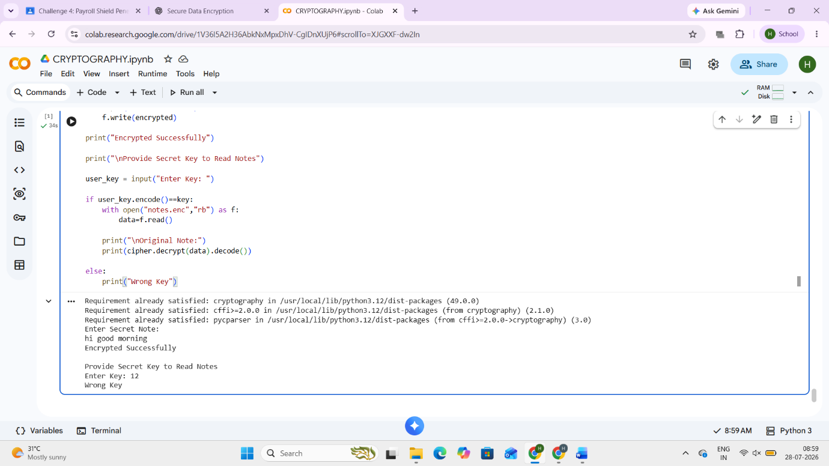
Problem 3: Confidential Hospital Records
!pip install cryptography
from cryptography.fernet import Fernet
key = Fernet.generate_key()
cipher = Fernet(key)
pid=input("Patient ID: ")
name=input("Patient Name: ")
diagnosis=input("Diagnosis: ")
prescription=input("Prescription: ")
record=f"""
Patient ID:{pid}
Name:{name}
Diagnosis:{diagnosis}
Prescription:{prescription}
"""
encrypted=cipher.encrypt(record.encode())
with open("hospital.enc","wb") as f:
f.write(encrypted)
print("Encrypted Successfully")

print("\nAuthorized Access")
data=open("hospital.enc","rb").read()
print(cipher.decrypt(data).decode())
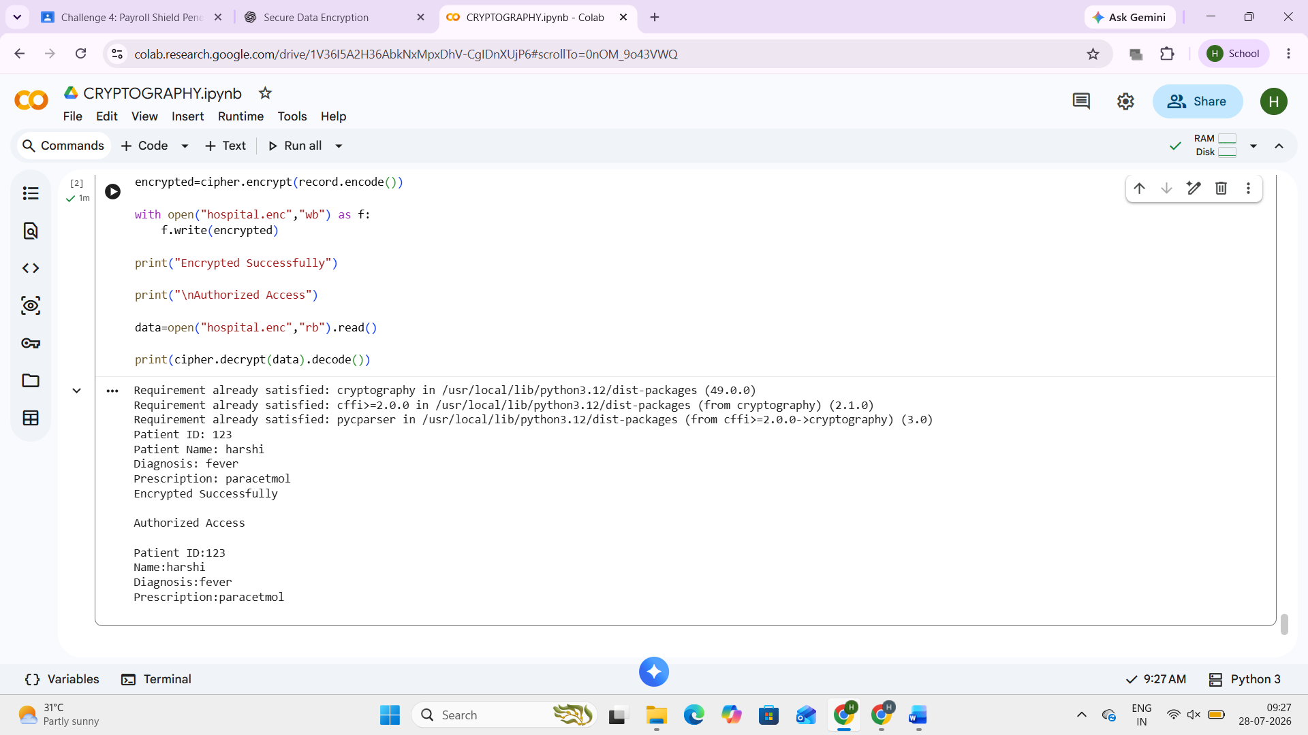
Problem 4: Secure Employee Database
!pip install cryptography
from cryptography.fernet import Fernet
key=Fernet.generate_key()
cipher=Fernet(key)
name=input("Employee Name: ")
salary=input("Salary: ")
record=f"""
Employee:{name}
Salary:{salary}
"""
encrypted=cipher.encrypt(record.encode())
with open("salary.enc","wb") as f:
f.write(encrypted)
print("Salary Stored Securely")
password=input("Administrator Password: ")

if password=="admin123":
data=open("salary.enc","rb").read()
print(cipher.decrypt(data).decode())
else:
print("Unauthorized Access")
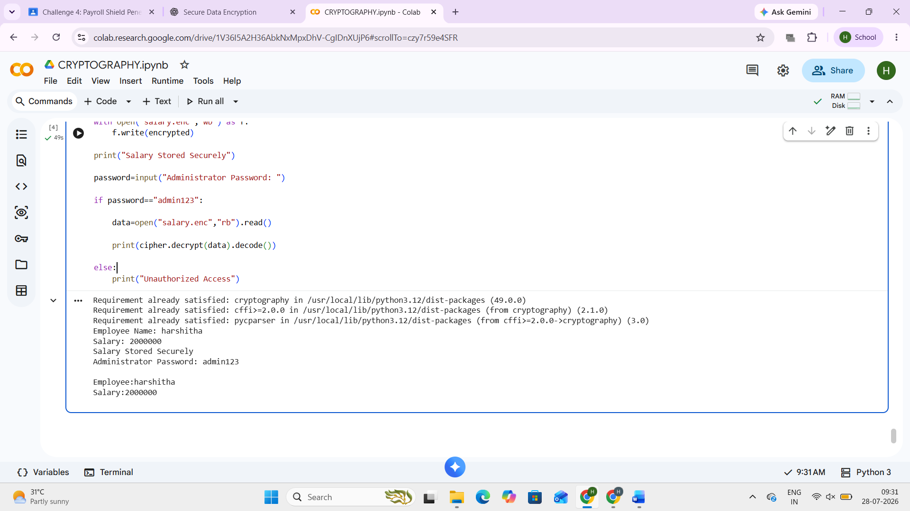
Security Audit – Student Application
with open("students.txt","w") as f:
f.write("Harshitha,12345,92")
print(open("students.txt").read())
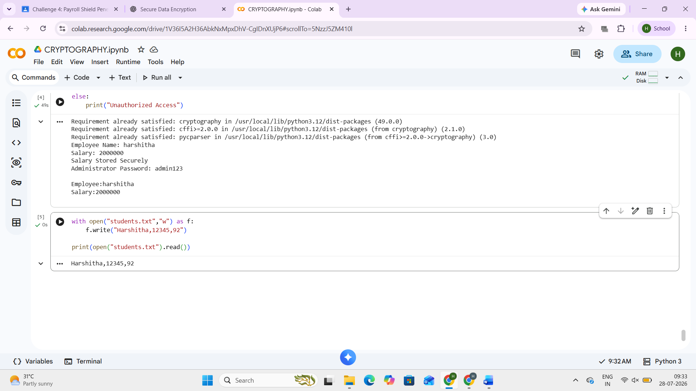

Security Audit – Secure Notes
with open("notes.txt","w") as f:
f.write("ATM PIN : 1234")
print(open("notes.txt").read())

